

Get Started: Banner Basics

Training Documentation

Banner 9

Updated: 4/21/2021

1. Logging In
2. Using Chrome or Firefox, log in to goPFW at <https://go.pfw.edu> with your network username and password.
3. Click on the Employee tab.
4. Locate the “Log in to Banner 9 Admin” link (on the right-hand side).
5. A new tab will launch and the system will automatically log you into Banner PROD. Whenever you change your network password, the system will update your Banner password to match your network password.
6. The Application Navigator (Welcome Screen) appears.
7. Navigating from Application Navigator to Forms

There are different ways to navigate to Banner forms:

1. Type the name of the form into the large Search bar in the middle of the screen, click on the form you want to use.
2. Using the Search icon in the left-hand navigation, you can type the name of the next form you would like to go to and press enter.
3. Using the Recently Opened icon in the left-hand navigation, you can navigate to and from any form that you’ve already opened.
4. Using the Favorites icon in the left-hand navigation, you can navigate to all your favorite forms.
5. Left-Hand Navigation

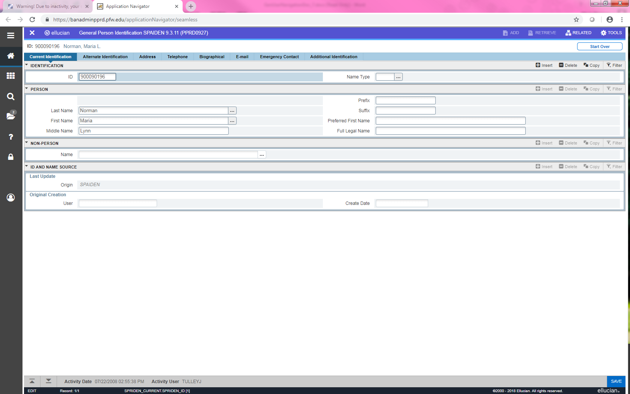 Toggle Menu – this icon will expand and collapse your left-hand navigation

 Dashboard – this icon will take you back out to the main landing page

 Applications – this icon opens Banner and My Banner (your preferred Banner forms)

 Search – this icon will allow you to search banner forms. You can enter descriptive names or the Banner acronym for the page.

 Recently Opened – this icon displays the number of forms you visited during a Banner session. Click on the icon and select a previously visited form to re-access it.

 Help – this icon will display help information about the page you are currently viewing.

 Favorites – list of frequently used forms you can set up

 Sign Out – this icon will safely sign you out of your Banner session

 Logged in User – hover over this icon and it will display your name



**Setting up your Favorites in Banner**

1. Using the main search bar on the Welcome Screen, type the name of the form that you would like to add to your Favorites menu.
2. As the form name appears, you will see a star  to the right of the form name.
3. Click on the star to fill it in 
4. The form will now be a part of your Favorites menu.

Making Edits to your Favorites Menu

1. Type GUAPMNU in the Search Bar
2. Click on the Go button in the top, right-hand corner
3. On the right-hand side of the screen, you will see your list of favorite forms.
4. If you would like to edit the form description you can, this way the description is more meaningful to you.
5. Click the Save button (lower right-hand corner) ; exit the form.

***Note: for your edits to show up you must log out of Banner and log back in.***

1. Upon logging back into Banner, click on Favorites
2. Now your list is up to date. If you would like to remove a form from your favorites, you can do so by clicking on the star to the right of the form name.
3. Navigating Forms

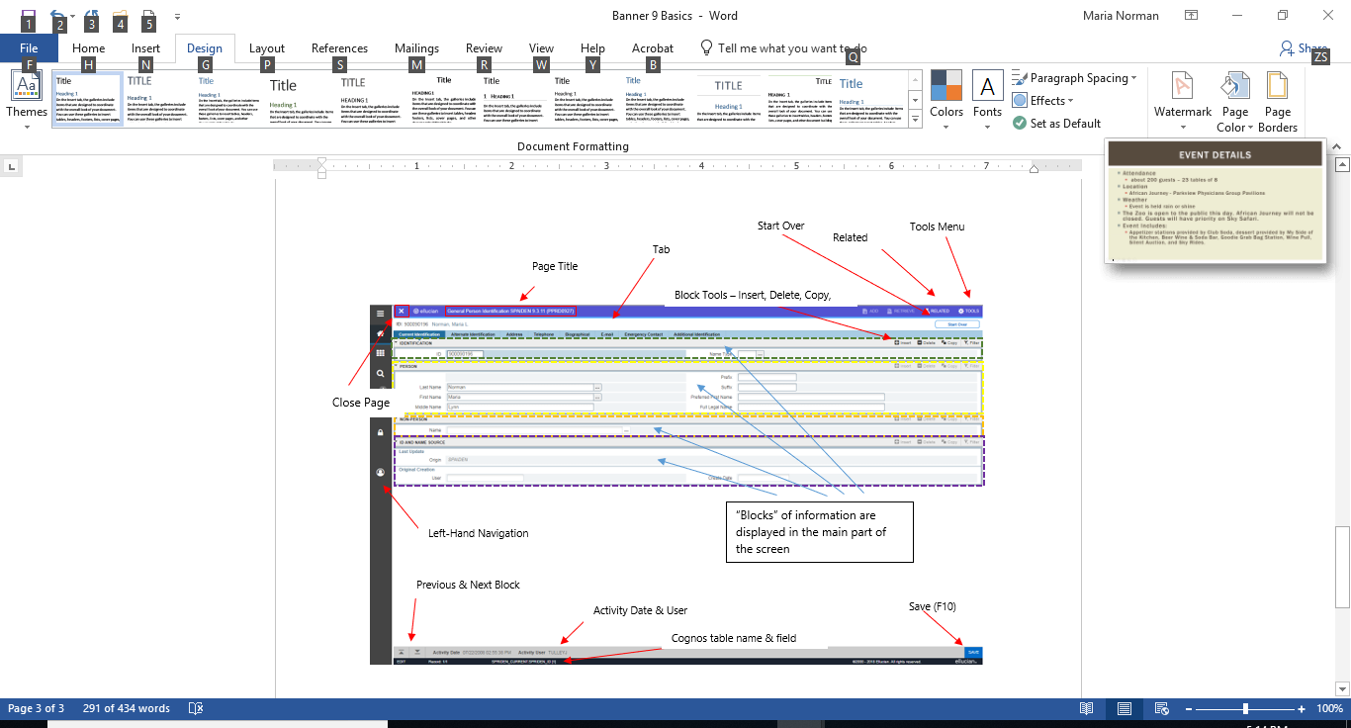

|  |  |  |
| --- | --- | --- |
| Task | Icon | Description |
| Related Menu |  | Displays a list of pages that are related to the current page and may be accessed from this page |
| Tools Menu |  | Tools Menu includes Refresh, Export, Print, Clear Record, Clear Data, etc. |
| Start Over |  | Roll back to the front of the current form |
| Insert |  | Insert a new record |
| Delete |  | Delete the current record |
| Copy |  | Copy a record |
| Filter |  | Filter or query the data |
| Save |  | Saves changes |
| Previous & Next Section |  | Use to go to the Next Section or Previous Section |
| Page Close Icon |  | Closes your current page |